Lincs About Town
The Big Idea
Learning Resources for Group Leaders

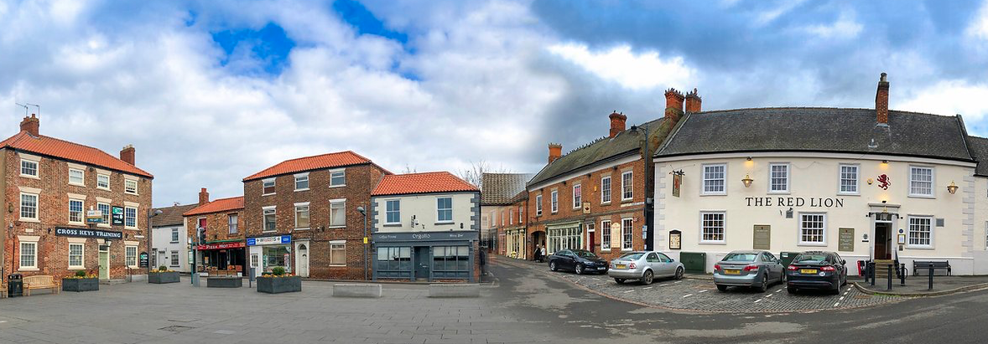

Contents

Introduction page 3
Structure page 4
Tips for Session Leaders page 5
Arts Award Discover and Explore page 7
The Big Idea Aims page 8
The Big Idea Session Notes page 9
Session 1 The Big Idea (creative thinking) page 10
Session 2 Project Planning page 16
Session 3 Creating Content page 20
Session 4 Creative Production page 23
Session 5Presenting the Big Idea page 31

Written by Innovate Educate Ltd for Lincolnshire Historic Environment Record, 2020

Introduction
Lincs About Town is part of the Extensive Urban Survey (EUS) funded by Historic England and Lincolnshire County Council. Historic England started the Extensive Urban Survey, surveying towns, in 1992 and is working its way round the country. The project in Lincolnshire began in 2018. The Project Officer, an Archaeologist, is carrying out research to compile detailed reports on 30 towns.
Alford, Barton upon Humber, Boston, Bourne, Brigg, Caistor, Cleethorpes, Crowland, Crowle,Epworth, Gainsborough, Grantham, Grimsby, Holbeach, Horncastle, Hykeham, , Kirton in Lindsey, Louth, Mablethorpe/Sutton on Sea, Market Deeping, Market Rasen, Scunthorpe, Skegness, Sleaford, Spalding, Spilsby, Stamford, Wainfleet, Woodhall Spa, Wragby.
Eleven towns benefit from an extended outreach programme. These are:
Boston, Cleethorpes, Crowle, Epworth, Gainsborough, Grantham, Holbeach, Horncastle, Scunthorpe, Sleaford and Spalding.
The project documents the historical and archaeological background and character of 30 Lincolnshire towns. At the end of the project each town will have its own section on the LincsAboutTown website sharing:
- Historic Urban Character Types (HUCT)
- Historic Urban Character Areas (HUCA)
- Heritage Values.
This is a live project, running from 2018 to 2022. The Project Officer is approaching the task town-by-town. She is gathering evidence from Ordnance Survey maps and documents held at Lincolnshire’s Historic Environment Record. She then uses a QGIS system to map the evolution and changes of each town. Initially intended for planners, this work provides a context to historical and geographical investigations and fieldwork.
These resources are part of the engagement programme for Lincolnshire’s Extensive Urban Survey, supporting heritage groups and youth group leaders to engage young people with local heritage for young people in schools and youth groups.
These sessions are aimed at young people aged 10+. They support session leaders to engage young people with local cultural heritage. They are ideal for heritage groups wishing to engage young people, or after school clubs.
Sources of information
It is not possible to include assets for every town in this resource, however, teachers can access assets to illustrate the story of a town through the Lincs About Town website or through Lincolnshire HER.
HERs across the country record all things known about the historic environment of our places. Their information about places, including our towns, comes from archaeological reports, old books, images, maps, aerial photographs and local people. This information is recorded in a database and plotted on a map. This information is publicly accessible and free to use in a classroom setting.
Not everything in the HER can be included in the database records, so if people want to find out more about where information comes from, they can either look for the sources used to create the record, or they can ask the HER staff for help.
Lincolnshire Archives look after old documents and the museums look after all the artefacts or objects.
Both contemporary and old photographs of buildings in local towns can be sourced from the Lincolnshire Archives via LincstothePast by searching the Illustrations Index. Email ArchiveCopies@lincolnshire.gov.uk

Structure
The resource contains:
Tips for session leaders including guidance on Arts Award.
Session notes
- The Big Idea (creative thinking)
- Project Planning
- Creating Content
- Creative Production
- Presenting the Big Idea.
Session leaders will find supporting and complementary resources on the Lincs About Town website including:
- Background Information (generic information that can be used in a local context)
- Lincolnshire Through Time (a brief overivew of life in Lincolnshire at historic periods most commonly taught in schools with references and activity ideas)
It is not possible to include assets for every town, however, session leaders and teachers can access assets to illustrate the story of a town through the LincstothePast website or through Lincolnshire HER.

Tips for session leaders
Working with young people can be hugely rewarding. Here’s some great advice from young people to session leaders.
Tips from young people
Young people of all ages want to:
- Be inspired
- Work with experts
- Produce a creative response
- Share skills to stimulate a community project
- Share their best work.
The essential ingredients for a great session are:
- Wow! Sessions must produce Wow! The Wow! is achieved through immersive, hands-on, interactive, ‘must do’ experiences
- Expert. Young people like to work alongside experts on live projects where possible
- For everyone. Sessions must be accessible, inclusive, empathetic
- Unique. Sessions must be unique, not easily delivered in school or elsewhere
- Legacy. Young people want to create a legacy by leading/devising a community project
- Focusing on the past, present and future. Young people enjoy researching the past, with a view to looking at the impact on behaviour now and in the future
- Linked to awards. To add value, sessions can contribute to Arts Award.
Ideally sessions are delivered through:
- Innovative learning models
- Using new technology
- Input from experts and skilled facilitators
- Telling the stories of Lincolnshire’s towns.
Young people enjoy exploring the big questions and themes around identity, community and social responsibility. They are also interested in sustainability.
For a great session
- Share your enthusiasm, it is infectious.
- Be encouraging. Praise effort not just results. Give positive feedback.
- Encourage young people to think for themselves. Question their questions and answers. Engage with them as experts in their own lives.
- Provide opportunities for interaction and discovery. Young people want immersive, interactive experiences.
- Involve everyone. Learning outside the classroom provides a different setting for young people to shine, particularly those who might not always shine inside the classroom.
- Young people don’t want to be talked at. Make it a conversation. Teachers are now advised to talk for no more than a minute at time before giving students something to engage with actively.
- Young people don’t want to be told off. This comes down to clear communication. If young people can’t touch an object, that’s fine, just tell them by setting expectations prior to the activity. Better still involve young people in setting the rules for situations, particularly where risk might be involved.
- Show young people how to do things. Young people are familiar with technology and if they are shown how to do something, clearly, twice, they generally can do it. Showing and getting them to teach each other is a great way to engage them in learning.
- Allow young people to ‘play’ with kit where appropriate. Playing with a purpose will help them to learn how things work. If using this technique, explain that they will then be asked to teach other young people what they have learned. Let them become the experts.
- Working with experts and other adults is a fantastic opportunity for young people to challenge their own and others’ perceptions. Teachers often report being hugely impressed with young people who have surprised them when given the opportunity to work in a different context.
- If asked, young people will provide a range of ideas for engagement that will give experts guidance for the tone and type of activity they find fascinating.
- Let go of the idea of the perfect result. The process is just as important. Allowing students ownership and agency over their own work will encourage greater creativity and reap huge rewards for all.
And finally…
- Working with young people of all ages means pitching your delivery to the appropriate level. You don’t have to talk down to students or, necessarily, avoid jargon (but do explain it). Introduce new ideas clearly. Young people will remember things that challenge what they think they know. They enjoy having insider knowledge. This will allow them to become experts.
- Remember what seems normal to you may be very alien to others not working in your field. This applies to adults but particularly to young people. If young people have a clear context, they can then feel confident to ask relevant questions and guide their own learning.
- With very young children, consider engaging them through their experiences and immediate environment (what can they see, touch, smell, hear etc). Expand from this point. Children enjoy active learning: setting their own goals, planning, exploring, reviewing what they have learned. They will do this if they are confident and secure in their environment and clear about expectations.

Arts Award Discover and Explore
The activities in this resource focus on creating a heritage or arts trail. The sessions can support young people interested in achieving Arts Award Discover and Explore. Arts Award Discover is an introductory award requiring 20 guided learning hours. To achieve an Arts Award Discover, children and young people need to log experience of:
- Taking part in arts activity
- Researching artists or craftspeople and their work
- Sharing their art discoveries.
For more information and training opportunities visit https://www.artsaward.org.uk/site/?id=2300
Arts Award Explore is the next step, requiring 25 hours of guided learning. Children and young people need to log evidence of:
- Taking part in a range of arts activities, including a personal response about what has inspired them about taking part
- The work of artists or craftspeople and arts organisations
- Creating a piece of artwork
- Sharing with others what they have enjoyed and/or achieved through completing their Arts Award.
Arts Council, England provides training for organisations wishing to engage young people through the Arts Award Scheme. There are several organisations across Lincolnshire that have Arts Award Supporter status. Arts Award Supporters are typically arts centres, heritage venues and schools. To find the nearest, follow this link.
Creative learning for Arts Award
There is a separate resource to accompany this resource, Creative learning for Arts Award. This provides ideas specifically designed for group leaders wishing to offer Arts Award.
The Big Idea
Aims
The aim of these resources is for young people to design a new creative town trail to engage local people and visitors. The sessions will develop a number of skills including:
- Creative thinking techniques
- Presentation
- Project management skills and creative production.
- Teamwork.
All will build from strong historical and geographical research skills.
Outcomes
- Build a sense of identity rooted in the local community
- Broaden horizons
- Develop enquiry skills
- Provide opportunities for young people to carry out research, fieldwork, create displays, exhibitions and share their findings.
The guiding principles for the resources are built around research with young people. They enjoy learning by:
- Working with and alongside experts
- Asking questions that are important to them
- Listening but also having their voices heard
- Creating a response to what they see, hear, feel, touch, even taste, and learn
- Seeing their work displayed or making an impact in the wider community
- Working with people of all ages for the good of their community. Some even want to work alongside (or competitively with) adults including parents/carers.
The resources complement Historic England’s Heritage Schools Programme. More detailed information and further teaching resources are available on 'Lincs to the Past' which also contains a timeline for Lincolnshire.

The Big Idea Session Notes
Here are five, hour-long sessions designed to support young people to design a trail. The sessions are:
- The Big Idea (creative thinking)
- Project Planning
- Creating Content
- Creative Production
- Presenting the Big Idea.
Timings are approximate. Each of the sessions can be a catalyst leading to further independent work if young people require more time to develop their ideas.

Session 1 The Big Idea
Introduction (5 mins) | Resources
Introduce Lincs About Town. There is a short video (at the foot of the page), where the Project Officer introduces the Extensive Urban Enquiry. Explain that this is a live project. The project aims to plot the stories of Lincolnshire towns by looking at geographical and historical data. | Lincs About Town website  Video
Brief (5 mins)
Create a trail or tour to engage local people and visitors with the past, present and future of our town
Explain that the Project Officer for Lincs About Town would like local young people, working in groups of 4 or 5, to bring the heritage of their town to life for local people and visitors. The trail or tour can be interpreted in many ways but it must be based on historical fact and be relevant to the present. It is for young people to decide what their tour or trail will look like.  Trails or tours can be very simple themed trails, but they could equally be mini festivals, a play with scenes performed in sequence around a town, Flash Mobs, digital stories that will attract interest via social media, actual themed stories, pop-up musical events or outdoor art trails. They may be digital or paper based. They could be around artwork, commissioning artists to create interpretations of characters or stories. However, it is important that ideas come from young people. Trails and tours must be engaging, and they must showcase the heritage and culture of the town’s past, present and (potentially) future. | Visual cues
Explore - What’s the big idea? (20 mins)
Start with an idea generation session. Invite young people in small groups (4 or 5) to come up with as many ideas as they can to generate innovative new trails/tours.  1. Set a time limit: 10 minutes  Invite young people to write or draw all the ideas they can think of on a piece of flipchart paper. If working online ask them to use the Whiteboard facility or chat. Stick to the 10-minute time limit even if ideas start to dry up. Having extra time will prompt more ideas.  2. Go for quantity rather than quality  The concept of generating ideas is based on coming up with lots of ideas, however ‘out there’ or impractical). Quality will be evaluated later.  3. Write everything down  Record everything, even jokes. Writing these down makes them available for others to use as triggers and so create more ideas.  4. Build on ideas as they are generated  Writing ideas down means young people can take an idea and build on it, either by putting more detail into it or by using it as the starting point for a new idea.  5. Do not judge or evaluate ideas during the ideas generation session  When generating ideas young people can put forward ideas that might usually be rejected later. Anything goes. In ideas generation, bad ideas do not exist. Every idea has value and so include everything. | Flipchart paper/  Whiteboard  Post-its  Pens
Select the best ideas (15 mins)
When the time is up, look at the ideas and start to group them into themes.  Review the ideas are there any duplicates, similar ideas? Any popular themes? If there are clear preferences, within each group, great. With consensus the group can move forward.  If not, young people may choose to run a pairwise comparison. In this exercise young people compare each idea against all of the others. Use the resource below. | Pairwise comparison grid and notes
Share ideas (15 mins)
When young people have decided on an idea to develop invite them to work up their ideas enough to share with the rest of the group. Share and ask for feedback. Again, reiterate this is a positive and safe environment to discuss ideas. The group is looking for constructive comments.
If young people want to test the viability of their idea, suggest using De Bono’s thinking hats. The Green, Yellow and Black hats tend to drive decisions along.
Arts Award
If young people are taking part in the Arts Award, invite them to start a reflective learning log and document their journey.
Idea generation and selection tools
Pairwise comparison
To use the process, first list the ideas in a grid. Then compare the ideas in pairs and ask the question – “If we had to do one of these and only one, which one would we choose?” We ignore all the other ideas at this point. For each pair, write the preferred option in the box. Once the grid is complete, the number of “votes” indicates the relative attractiveness of the ideas, e.g.: Below Idea 3 has the most votes.
 | Idea 1 | Idea 2 | Idea 3 | Idea 4 | Idea 5
Idea 1 | - | - | - | - | -
Idea 2 | Idea 1 | - | - | - | -
Idea 3 | Idea 3 | Idea 3 | - | - | -
Idea 4 | Idea 1 | Idea 2 | Idea 3 | - | -
Idea 5 | Idea 1 | Idea2 | Idea 3 | Idea 5

Note
- It is important that every comparison has a winner and a loser. It is not possible to have a draw.
- Ideally there should be unanimous agreement on each comparison. If not try to achieve consensus.
- The final priority order is a guide only. Young people are free to adjust it if there is a consensus but it is important to be open and honest about the reasons for doing this.

Six Thinking Hats
Edward de Bono’s thinking hats is a great tool to work out the viability of ideas. Everyone approaches new ideas in different ways; they might be optimistic, ‘That’s a great idea, let’s do it’ or they might be cautious and say, ‘But the problem with that is…’.
With the thinking hats, everyone assumes one mindset at the same time and explores the idea from that mindset, they then move on to explore the idea in the next mindset. For example, the Red hat is all about emotion, a gut feeling, The Blue hat is all about thinking around an idea, the ‘what ifs’. Viewing an idea through the lens of the Green, Yellow and Black hats on a continuous cycle will lead to a refined and workable idea or an abandoned idea.
The Yellow hat is optimistic and sunny; it’s all about why we should do something. What we hope the outcomes will be.
Green hat is associated with creativity and growth; what a great idea but we may need to modify it – here’s how…
Black hat is careful and cautious; what might the barriers be?
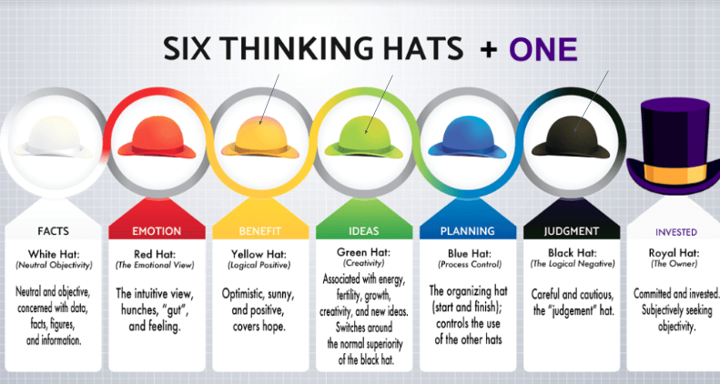

Session 2 Project planning
Introduction (5 mins) | Resources
Summarise the project and recap progress so far. There is a short video (at the foot of the page), where the Project Officer introduces the Extensive Urban Enquiry. Explain that this is a live project. The project aims to plot the stories of Lincolnshire towns by looking at geographical and historical data. The brief is to:  Create a tour to engage local people and visitors with the past, present and future of our town. Young people have defined an idea to progress. | Lincs About Town website  Video
What’s the plan (20 mins)
Having decided on the type of trail, young people now focus on how to make this a reality through project planning.  Prompts, consider the Who, What, Where, When, Why and Hows?  Ask young people to shape their plan. They need to consider Who, What, Where, When, Why and How? in the context of:  - What will they deliver and why? Objectives?  - Who is the plan for? Stakeholders and audience?  - When and where will it take place? The practicalities, schedule, venue, build)  - What will it cost? (budget)  - What are the risks?  - What does success look like? Visualise the project’s best outcomes.  Planning the project in detail  To decide  Who will be involved in delivering the project?  What will each person do? What are their strengths? Do they want to work to their strengths or develop a new skill?  Together, how will you implement the plan?  Who will be the audience? Are they old? Young? From the town? Tourists?  What does the trail look like?  Where and when will it take place? Will it be permanent or temporary? Will it be seasonal? Will it link with other important events? What about Heritage Open Days, Fairs or a Fun Palace?  How will it happen? Will the trail be digital? Will it be guided? Will it be about knowledge, fun or challenges? | Flipchart paper/  Whiteboard  Post-its  Pens
Preparing to pitch (20 mins)
Ask young people to write down their idea and plan and prepare to share with the rest of the group in a short (no more than 5 minute) presentation. Businesses often use the Concept Memo tool to present and share ideas. | Concept Memo
Pitch the idea (15 mins)
Once young people have an idea and plan (or completed the Concept Memo), ask them to pitch the idea to the rest of the group. Invite positive feedback and constructive criticism to improve or support ideas.
Back in their groups, young people can revisit their plan using the thinking hats if necessary.
Arts Award
Remind young people to gather evidence from this session to add into their Arts Award reflective learning log.

Project Management Cycle

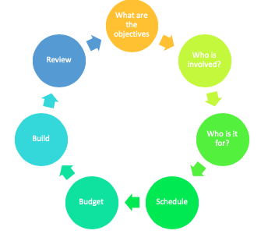

Concept Memo

Divide a sheet of A3 or flipchart paper into four quarters.

Description | What do we have to do to implement the idea? What do local people and visitors need to do to use the trail?
Capability | Why do we think we are able to implement this idea? Why do we think the local people and visitors will be able to use this idea?
Value | What benefits will come from introducing the idea? What benefits will the local people and visitors get from the trail?
Picture | The optional fourth section is a picture of the idea. This can be a detailed blueprint but a more abstract impression is better. The benefit of drawing a picture is that it introduces a different thinking style. This can lead to new insights. This is an optional, but highly recommended, part of the Concept Memo.

Session 3 Creating Content
The activities in this session could easily run over two or even three sessions depending on the group.

Introduction (5 mins) | Resources
Summarise the project and recap progress so far.  Brief: Create a tour to engage local people and visitors with the past, present and future of our town. Young people now have a detailed project plan. | Lincs About Town website  Video
Detail (30 mins at least)
This session is all about the detail. Young people research and create the content of their tour.  Young people explore the heritage of the town to find stories to share on their trail.  What do we know about the history of our town?  What do we know about the people of our town?  Whose stories are prominent?  Whose stories are missing?  Sources  Lincolnshire’s Historic Environment Record can provide archive material on request.  Lincs About Town records on specific towns. The Discussion document is a summary and great place to start.  Lincolnshire Through Time resource to accompany the Lincs About Town project giving an overview of what life was like at significant historic periods in Lincolnshire.  Lincs to the Past contains more resources and ideas to help young people explore Lincolnshire’s past.  Physical evidence  English Heritage awards Blue Plaques to commemorate people who died at least 20 years ago. The plaques are attached to buildings closely associated with the person. So the plaques link people and place. Civic Trusts often offer tours based on Blue Plaques. This could be a starting point for young people. Civic Trusts and other historical associations can share their existing tours and stories. If brave, they could invite young people to critique their tours. What works, what could be improved, what might they change for a different audience.  Use the Explore tool to look at the information young people have about the town.  What else would they like to know? | Paper  Pens  Crayons  Access to computer or iPads  Explore tool  Access to Computer  LincsAboutTown  'Lincs to the Past'  Explore tool
Analyse (15 minutes at least)
Use the Explore tool to summarise what young people know.  What do they know about their town?  Whose stories are told?  Is this important? Why?  How can young people tell more diverse stories (if these are missing)?  Which/whose stories would they like to explore further?  Then revisit the grid for each aspect of the town’s story young people would like to tell. | Explore tool
Start to develop content (10 mins)
In groups, select around six points of for the trail or tour. Use Story Maps  Start to scope out the stories that could be told around these points.  Share draft activities/scripts with the group.  How could these drafts be brought to life? | Story Maps
Arts Award
Remind young people to gather evidence from this session to add into their Arts Award reflective learning log.

Explore
What do we think we know?
What we know for certain?

What we think we know?

What’s the difference?
What do we need to know?

Why does this matter?

How will we find out?

Whose stories are told?
Whose stories are missing?

Why does this matter?

How can we change this?

Session 4 Creative Production
Introduction (5 mins) | Resources
Summarise the project and recap progress so far. Now young people have a big idea, a plan and they have started to research the content for their tour. This session is all about bringing their ideas together. What’s the format of the tour? | Lincs About Town website  Video
Map the trail (20 mins)
Using Story Maps, map the route of the trail. Draft the stories/background attached to these points.  Make sure the trail or the objects and elements making up the trail are in safe places and are at the right height for everyone to see.  Trails can be any or all of the following: fun, engaging, informative, challenging, interactive, at the right level for families and children of all ages.  Remind young people trails can be indoors in a museum or Town Hall or outdoors around the town or in the countryside. Look out for trails around town. You might spot blue plaques around towns. These show which buildings have a story to tell either about how the building was used or who used to live there. There’s a plaque outside Louth Grammar School to Alfred Lord Tennyson. There are other plaques telling some of Lincolnshire towns more gruesome stories. | Story Maps  Paper, pens, crayons, computers, iPads
Engaging audiences (30 mins)
Choose appropriate types of trail questions/text  Trail questions can fall into a number of categories:  Knowledge and understanding  - It’s a fact or Did you know? (obscure or challenging facts)  - Quiz questions  Skills/Challenge  - Investigate: How do we know …  - Share: take a selfie, (may need a mirror) Instagram ready, Tiktok.  - Solve a problem.  Fun and enjoyment  - Actions: Strike a pose/take a photo/selfie, recreate a scene, dress up  - Create, name, design  - Investigate: How do we know …  - Riddles  - Story telling  - Drama to tell a story that unfolds at different points in the town  - Music across the town  - Art trail.  Temporary, seasonal or themed trails  Temporary trails can be created by:  - (indoors) placing alphabet blocks next to selected objects on a theme. Children collect the letters (write them down) to make a word (Name of a person or place of interest for example).  - Providing words or messages on postcards to create clues to solve a puzzle  - Ask children to carry out simple maths using text or numbers of objects to unlock a code.  Trails can be created around objects, themes, people, events or seasons.  Outdoors a trail could lead runners, walkers, tourists to places of interest.  What does the trail look like?  Review: which questions or activities best suit their audience? | Paper, pens, crayons, computers, iPads
Arts Award
Remind young people to gather evidence from this session to add into their Arts Award reflective learning log. | Reflective learning log

Trail questions
These questions may be useful in a trail:
- What can you see?
- Did you know?
- How many can you see?
- What is your favourite object/type of X?
- What do you think it would feel like to touch?
- What is it made from?
- What sound does it make?
- What might it smell like?
- How old is it?
- Who might have used it?
- Write down all the words you can think of to describe this object?
These phrases can be used to start simple activities:
- How many
- Find similar and different
- Find out about (using quirky/investigative questions)
- List
- Draw (draw something that interests you about this object).
- Role play
- Write
- Find
- Act
- Copy the pose/recreate the painting (using a frame)
- Dress up.
Sample trails are provided at the end of this document.
Investigating, exploring and creative responses
Explorer bags
Contents of an explorer bag might be:
- Magnifying glass
- Clip boards
- Quiz sheet
- Story dice
- Disposable camera or suggest using phone camera
- Series of storybooks and ’Hands on’ history, geology, science related to the museum and vehicles.
Trail of (not very well) hidden notebooks or sketch books in tins (e.g. secured to a bench)
The tins contain paper, postcards, sketch pads, pencils or crayons with simple instructions such as:
- Write down your thoughts whilst waiting for the bus.
- Write down words to describe favourite objects without using its name.
This activity can be offered using postcards. Children can write their descriptions on postcards with the name of their favourite object. These can be posted and then used to:
- Write a poem (poetry boxes)
- Draw a picture (sketch boxes)
- Commission other visitors or people in the area (perhaps with a high profile) to create a poem or sketch.
Ask children to draw their favourite items. Put them in the order of the time they would have been made/used. Hang them on a line with pegs in time order.
Visual cues
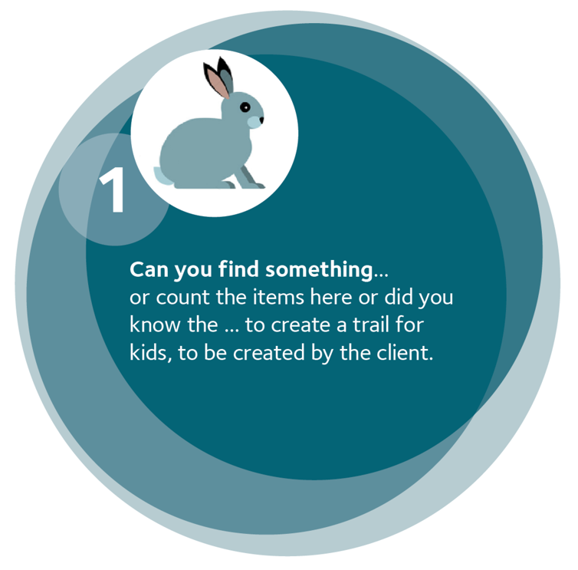
These disks were designed for a children’s trail in a museum.

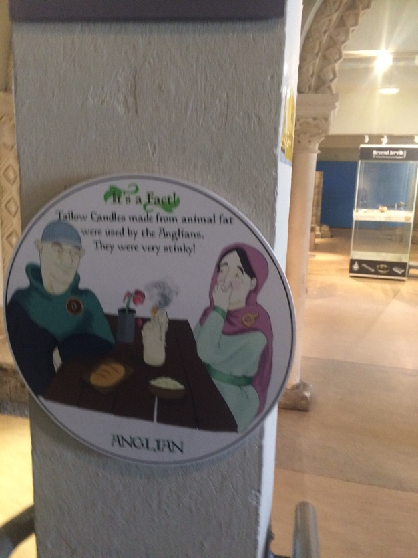

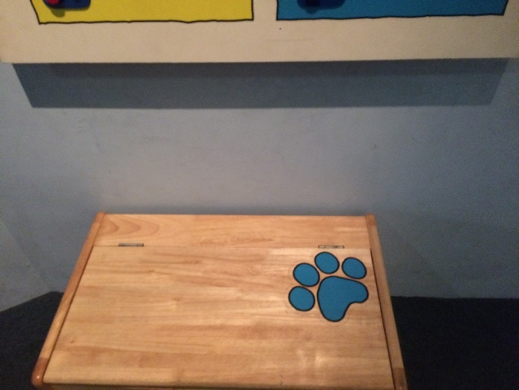

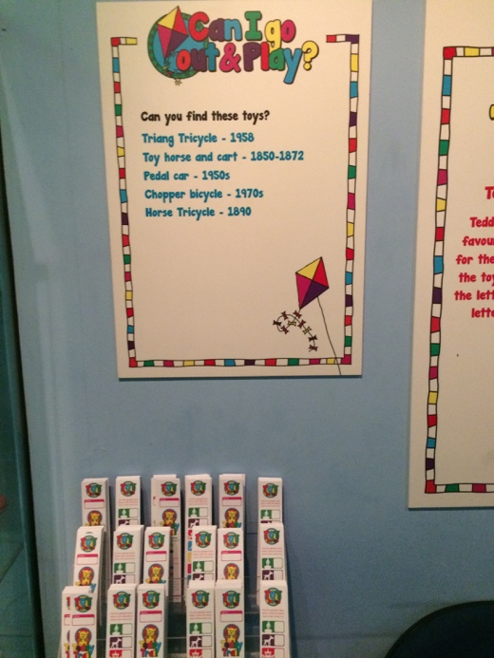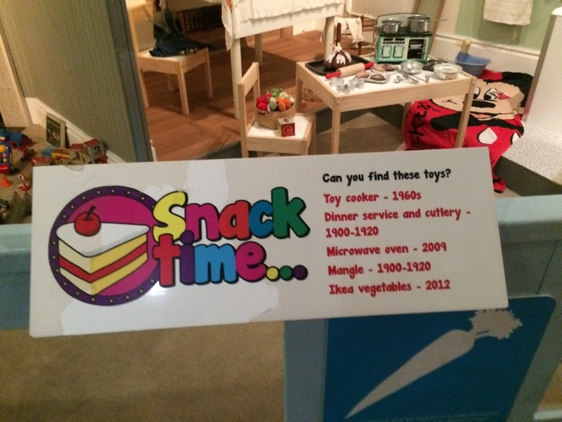

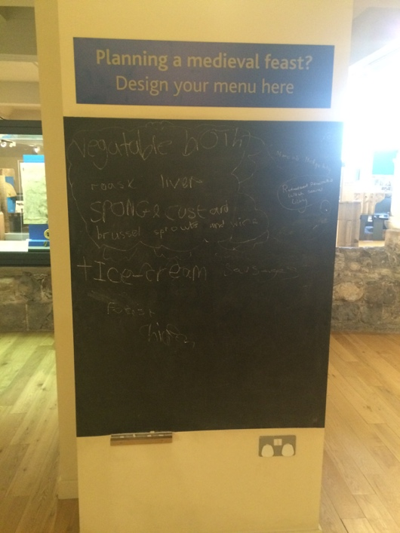
Examples of trails for inspiration
National Centre for Craft and Design arts NK - https://nccd.org.uk/community
At the foot of the page there is Ridges & Furrows Art & Heritage Trail https://www.ridgesandfurrowstrail.org/

Visit Lincoln also has a number of trails for visitors to the city and surrounding area https://www.visitlincoln.com/trails/

Several trail leaflets were created as part of the First World War Memories and Memorials project. Please see pdfs provided with this resource. Several were designed by children and young people.
XXXX These are supplied as PDFS for group leaders to download.

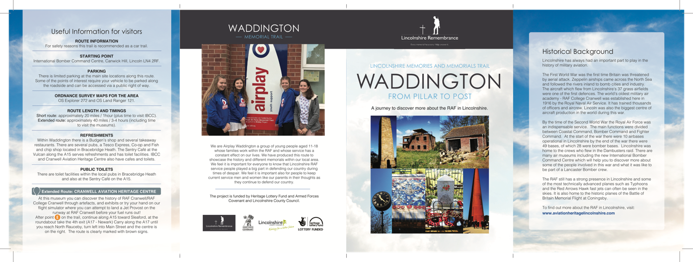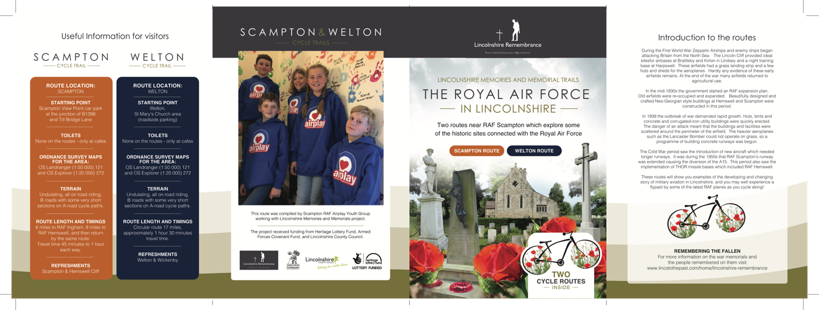

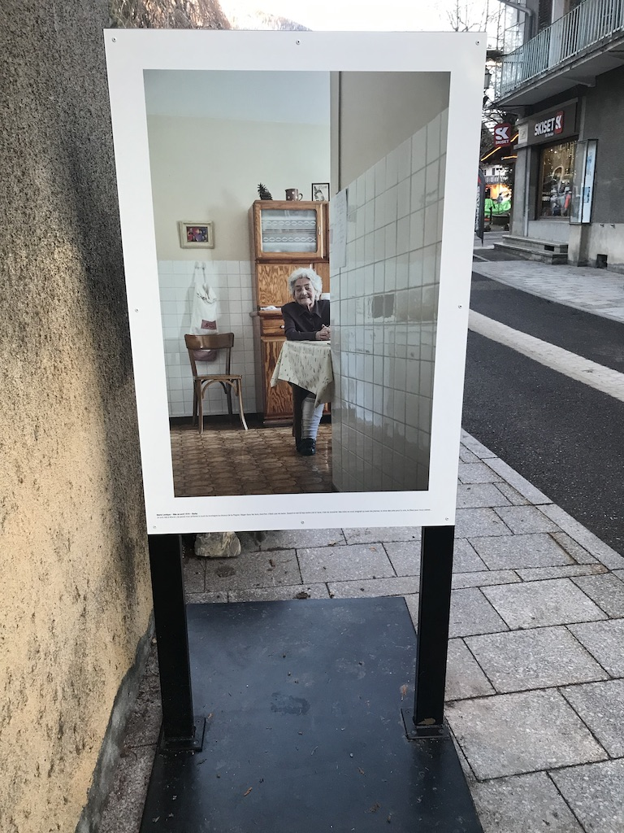
This is a photography exhibition in a street in a French Alpine town. It is celebrating the centenary of a local company through photographs of people in the area who are 100 years old or more. Each image has a couple of lines written by the person featured. The comments tend to be about sustainability, kindness, love, the importance of good relationships and a healthy lifestyle.

Session 5 Presenting The Big Idea
Introduction (5 mins) | Resources
Create a tour to engage local people and visitors with the past, present and future of our town.
Now young people have a big idea, a plan and they have developed content and know how their tour will look. This session is all about final design and make.
Ask an expert (15 mins) (option)
At this point young people may benefit from working with an artist or graphic designer to find out about their work and for the artists to judge their work. Working with artists will also contribute towards an Arts Award.  Invite the speaker to share their work, process and top tips. Allow young people to ask questions based on their experience. | Artist, graphic or digital designer
Refine their work (30-40) mins
Invite young people to review their work. What works and what could be improved?
Revisit and improve. Prepare to present the final trail. Ensure each member of the group has a role. Rehearse.
Present (15-20 mins)
Finally invite young people to present their trail to the group. There may be further opportunities to present the trails to heritage and other community groups in the town.
Arts Award
Remind young people to gather evidence from this session to add into their Arts Award reflective learning log. | Reflective learning log

Activity Mat

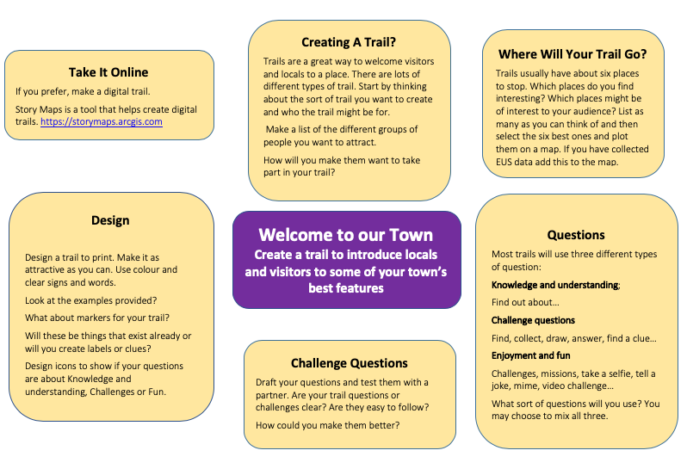

Creative learning and Arts Award
LincsAboutTown provides many opportunities for children and young people to be creative. These notes suggest the Arts Award as a framework for sessions. The Mighty Creatives is the Bridge for East Midlands. IVE is the Bridge for Yorkshire and the Humber. These organisations can provide more information about Arts Award Training and Cultural Learning Partnerships and funding.
Arts Award in England is awarded to young people aged 5-25 years, at five levels, one introductory level, Discover, and four further qualifications, Explore, Bronze, Silver and Gold, all accredited on the Qualifications and Credit Framework. At Gold level Arts Award offers 25 UCAS points. This resource can be used by Arts Award Assessors to support children and young people through Discover and Explore or can be used entirely independently.
The Arts Award framework is suitable for both formal and informal learning. It has the advantage of providing progression routes for young people whilst supporting them to develop leadership, research and arts skills in the broadest sense.
Getting started
These ideas are starting points for developing arts-based activities. These ideas are for Arts Award Discover and Explore criteria but each could be extended and developed further to support work at Arts Award Bronze, Silver and Gold.
Discover and Explore Part A
Discovering the arts all around you and taking part in and creating artwork.
After welcoming children and young people, explain the first task.
Children and young people can use all the senses starting to think about developing a heritage trail for their town. If on a field trip, or, from memory, perhaps by closing their eyes, ask what they can see, hear, listen, smell and where permitted, touch. Their town holds many fascinating and interesting stories. It is also full of shapes, colours, smells, designs, words, people, materials, sounds, signs.
Now ask them to focus in on arts or crafts. Discuss what these might be.
In groups of two or three, ask them to list (write down or record on mobile devices) as many different forms of art and craft that they have seen or can remember in their town.
The town is full of art and craft forms from the designs painted on shop fronts, to the type scripts used on signs, to advertising hoards, to designs on the sides of vans or lorries, to street furniture, to the shapes of buildings, to patterns in brickwork, to designs of doors and windows, and the materials used. Art and craft also play a part in the design and layout of the town and how its stories are told.
Creative arts
If you choose to take the children on a short field trip, with all health and safety risk assessments and procedures in place, invite children and young people to explore the town with heightened senses and repeat the activity above.

Invite children and young people to choose a building, feature or area that appeals to them and then:

  - Sketch the object or feature
  - Sketch it without taking your pencil off the paper
  - Sketch it without looking at your paper
  - Sketch it with your eyes closed.

Select a favourite building, not disclosing the choice to others, and then in pairs take turns to describe the building in five words and ask a partner to guess which one. If the partner can’t guess, try changing descriptive words.
Choose a building. Ask children and young people to imagine this building could tell all its secrets. Who has owned it? Who has lived or worked here? What happened here? What adventures does it hide? Help them to write a short story about their chosen building’s adventures.
Help pupils to record the different sounds that they hear in the town, both manmade and natural using digital sound recorders. Back in the classroom put the sounds together to create a soundscape. Soundscapes are used as an interpretative feature. Can children and young people recreate these sounds or melodies? Can they research the sort of music people might listen to when some of the buildings were first constructed? What was the purpose of some of this music? You can add artwork to this too. Use the app, ThumbJam, to create melodies. Using a pentatonic scale (in C) is probably the most kind!
Creative writing
Which art forms/technologies/crafts are used to tell the stories of the town and the people who live and work here? Which art forms might the children use to develop their trails?
- Which words would they use to describe places on their trail to someone who can’t see them?
- Which adjectives would they use to describe its shape, texture, materials, colour, size, use, age, dimensions?
- What is different about it from other buildings or features?
- What attracted them to it?
Create word banks for each of these ideas.
Can children create poem using the words in their word bank?
Can they imagine the people or person who may have lived or worked in their town many years ago?
Can they develop a character based on a person who may have lived or worked here?
Use the Lincolnshire through Time resource for useful background.
They can develop their creative writing skills by putting themselves in the shoes of the character completing the following sentences: I can see, hear, feel, touch, smell.,..
Ask the children/young people to design a costume for their character.
Ask them to create role cards that explore the characters of different people who may have used lived in their town. Ask them to use these role cards for re-enactment activities.
Art
In the town, young people can look at a range of buildings, objects, artefacts and maybe even artworks. Ask them to sketch details that they find interesting. They can then create their own artwork using the detail as inspiration when they get back to school/the youth group. Their artwork can be a drawing, a painting, a design for an item of clothing, a piece of jewellery, a lino-cut print or even an installation.
Young people may choose to look for objects that are similar or different. Ask them to focus on some of the following: colour, texture, shape, touch, movement, purpose, who made it, how was it made, what material was used etc.
Look at the buildings in the town in some detail for ideas and inspiration from other artists. Observation might lead young people to details/patterns in brickwork, other materials, window frames, ironwork, gardens, courtyards.
Sketch or photograph the features that are interesting. Use the sketches for further work to create a piece of artwork, printed fabric, wallpaper or a design for a new item to sell in a museum shop or a visitor information centre e.g. a mug, tea towel etc.
Drawing inspiration
Ask the children/young people to imagine they are a local artist. Tell them that the Lincs About Town Project Officer would like to commission a new artwork to tell a story from the local community. What sort of artist are they? Help them to research the history of their town and community. Again, use the Lincolnshire through Time resource for useful background.
Design and create a new arts and heritage installation to reflect an important time period in the history of their town.
Focus on the architecture of the buildings. Make sure that they photograph or draw some of the features.
Story telling
Ask children in pairs to choose a story they have heard in the town. Help them to recount and identify the main people and points in the story.
What are the key messages? How similar or different are these?

Discover and Explore Part B
Finding out about artists, arts practitioners and arts organisation:
To support young people to achieve this aspect of Arts Award:
- Provide opportunities for young people to meet creative practitioners.
- Help them to think about what sort of questions they would like to ask these creative practitioners to find out more about their work, their skills and their art forms.
- Help young people to record, creatively, what they have found out through, for example, annotated collages, timelines, drawings, film or sound recordings. They could also create their own piece of artwork in the style of your chosen artist, identifying the type of art, the styles, content and materials they have used.
- Help pupils to find out about craftspeople who have contributed to their town.
- Help pupils to find out about local craftspeople.
Arts Award Discover Part C Share and Explore Part D Present.
This aspect of Arts Award is about sharing experiences and skills learnt during the Arts Award journey.
Provide opportunities and events for young people to present their Log Books and journeys to each other, other young people and/or their parents/carers. This could include creating an exhibition that can be shown in school or at a local venue.
Help young people to plan and run their own creative heritage workshops or tours for other people to learn about their town. This will include training young people as facilitators/enablers and can be built into a volunteering programme.
Encourage young people to write back to you or create online diaries, Blogs, Vlogs etc. sharing what they discovered, learned and enjoyed through their Arts Award experience.
Share Arts Award journeys through assemblies, school exhibitions and celebratory events etc.

